SAP Build Set Up in Trial Account

Reference
Your top choice is to try free tier Get an Account on SAP BTP to Try Out Free Tier Service Plans. But just in case you wish to use trial account, this tutorial is here.

To follow the hands-on exercises, you will need to:
- Get an BTP Trial Account Get a Free Account on SAP BTP Trial.
- Set up SAP Build Process Automation
  - subscribe to Subscribe to SAP Build Process Automation Using SAP BTP Free Trial
  - Install agent for robotic programming automation: download Desktop Agent and install it (Link is for Windows OS only)
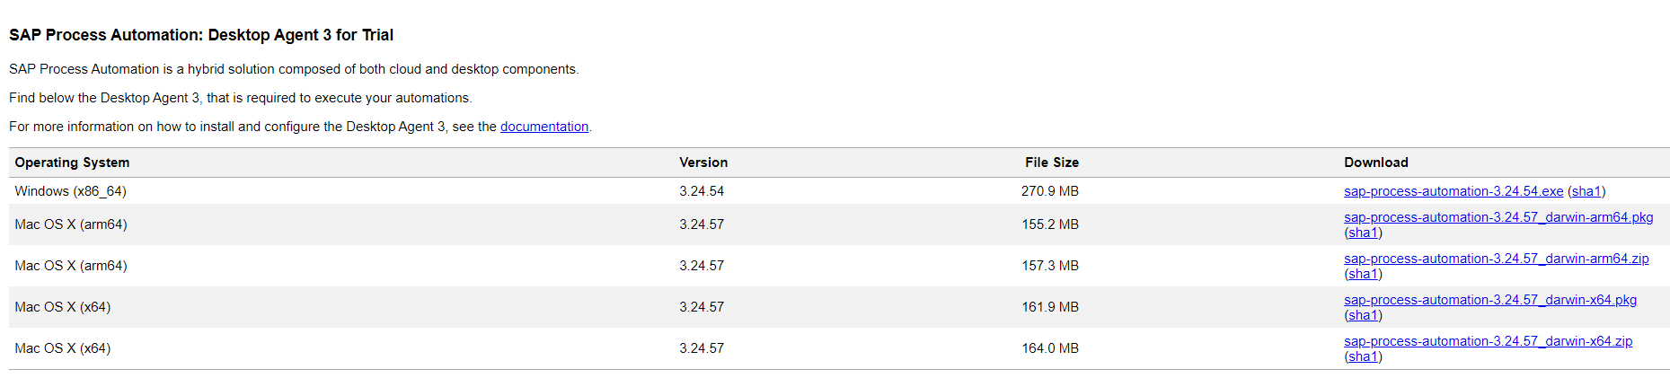
- Set up SAP Build Apps
  - BTP Trial Account Set Up SAP Build Apps (with Booster) on SAP BTP Trial Account
  - Install Preview app on mobile devices (from GooglePlay for Android phone or Apple Store for iPhone)
- Set up SAP Build Work Zone, standard edition Set Up SAP Build Work Zone, standard edition Using a Trial Account
- Set up SAP Build Code Set Up SAP Build Code using trial account

It will take some time to initiate so it is recommended that you set up the account before hand.

Steps
- activate the trial account.
- run the Booster to set up SAP Build Apps
- subscribe to SAP Build Process Automation
- install SAP Build Process Automation Desktop Agent
- install SAP Build Apps Preview app

Description | Screenshot
Register a sap account at www.sap.com, fill in your email address and phone number | 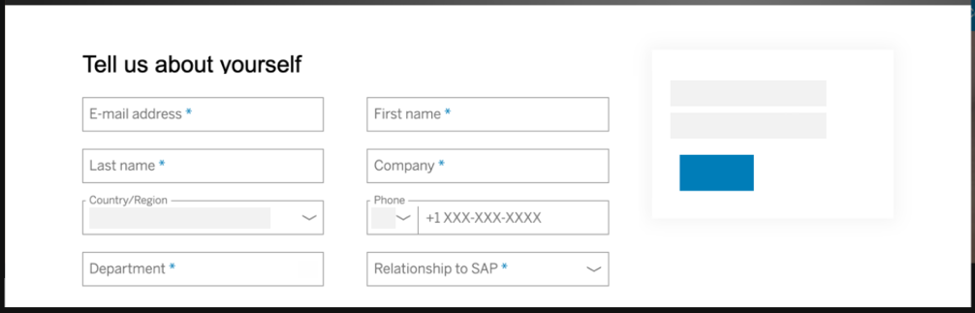
click https://account.hanatrial.ondemand.com/ to activate your trial account, choose region “UA East (VA)” for AWS, not for Azure. | 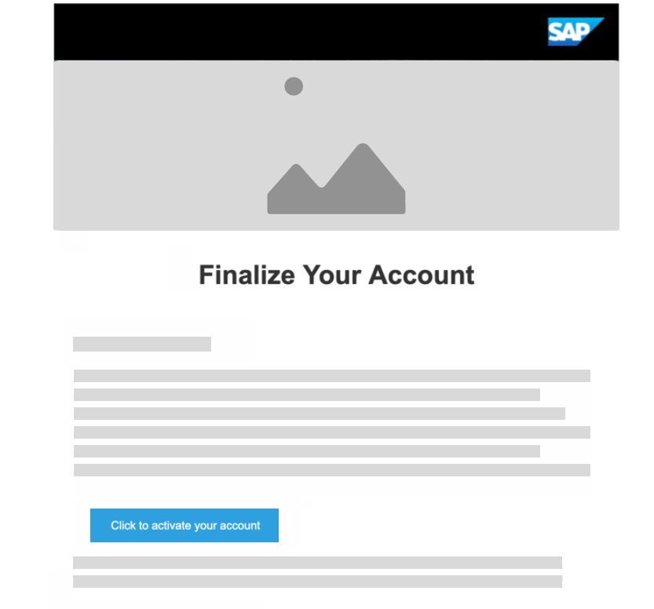
In your BTP Cockpit, click “Trial” to get into subaccount | 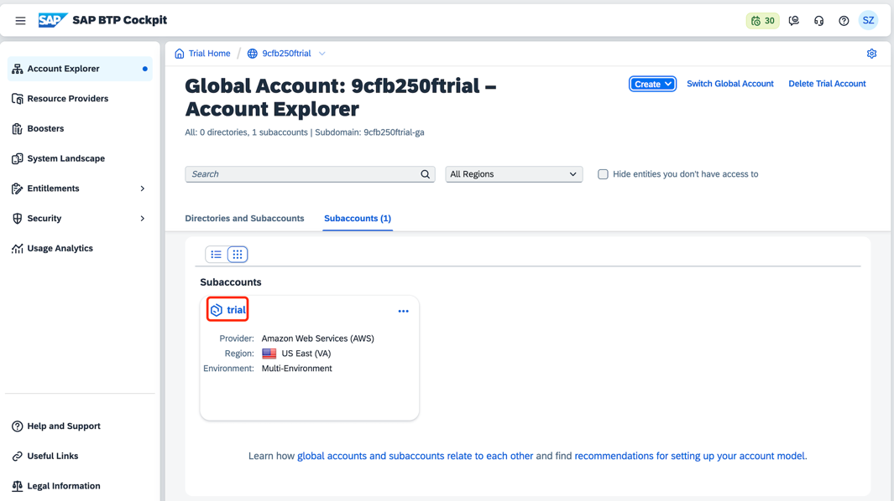
Go back to BTP Cockpit, click your global account, click “Booster”, search for “SAP Build Apps”, click “Start” to run the booster | 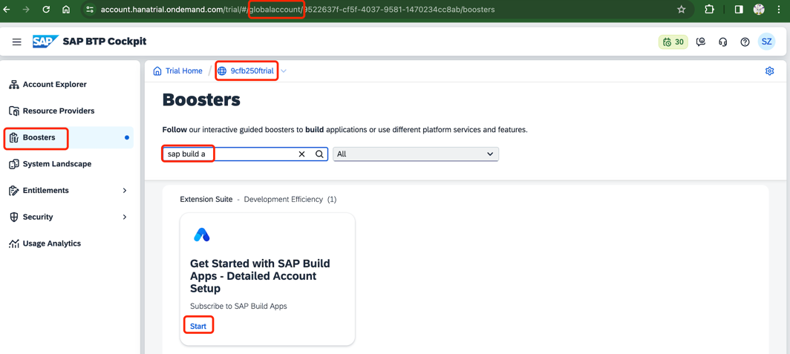
In the pop out wizard, click Next | 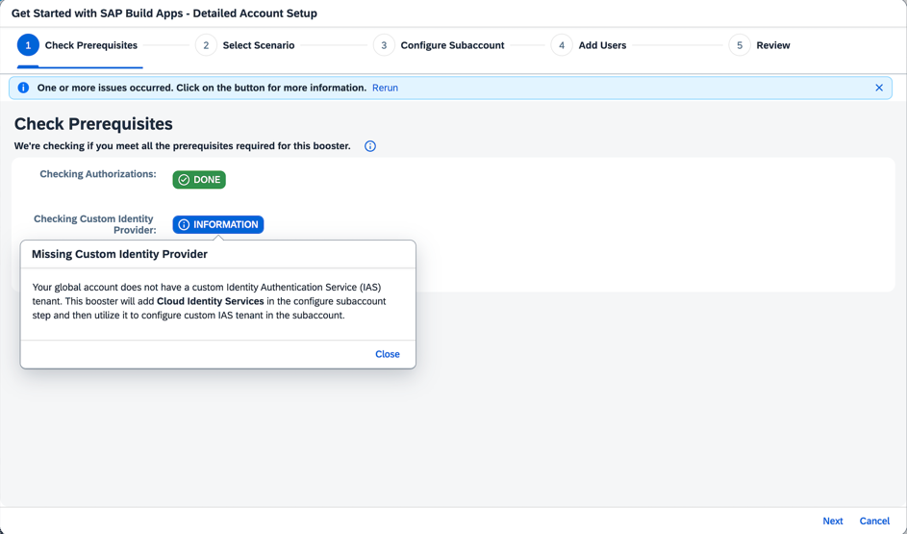
Choose “Select Subaccount”, click Next | 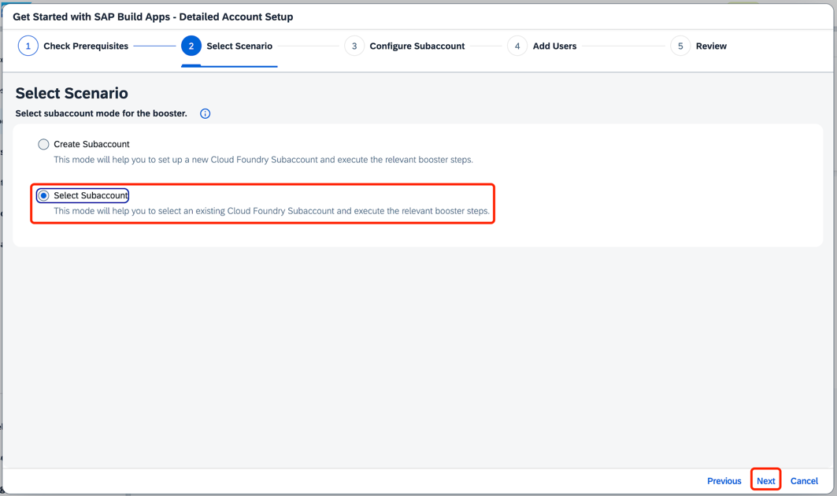
Choose the existing “Trial” subaccount, click Next | 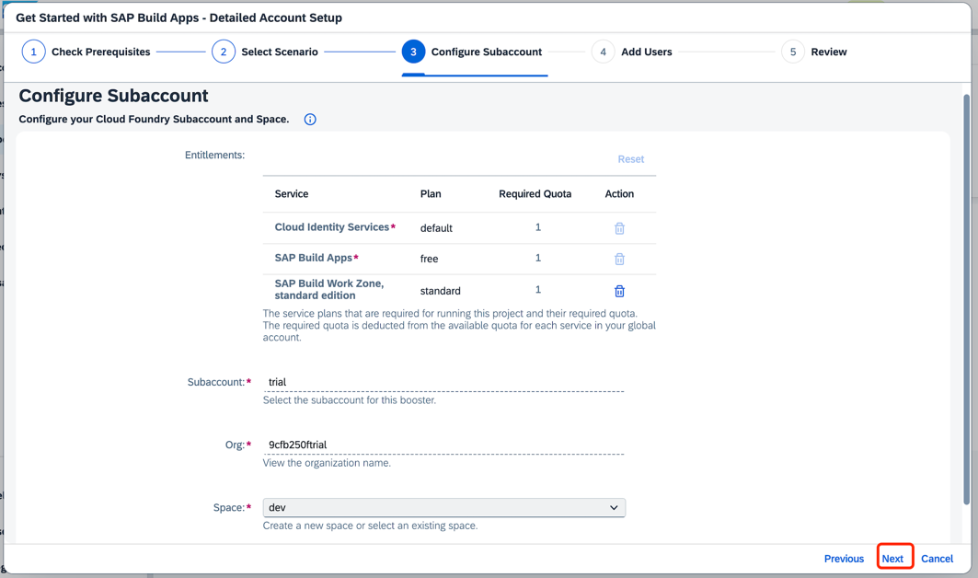
click Next | 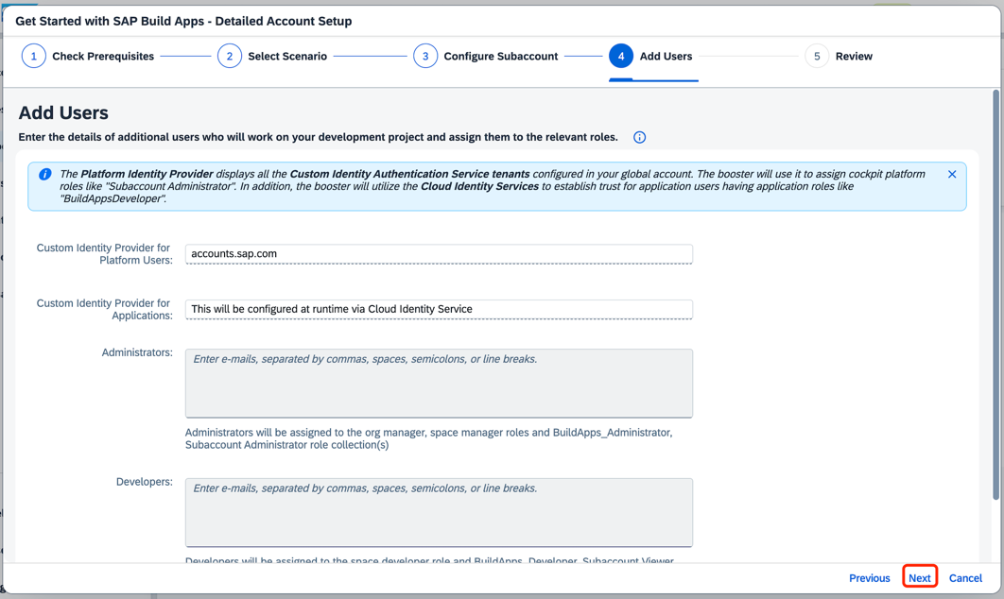
click Finish | 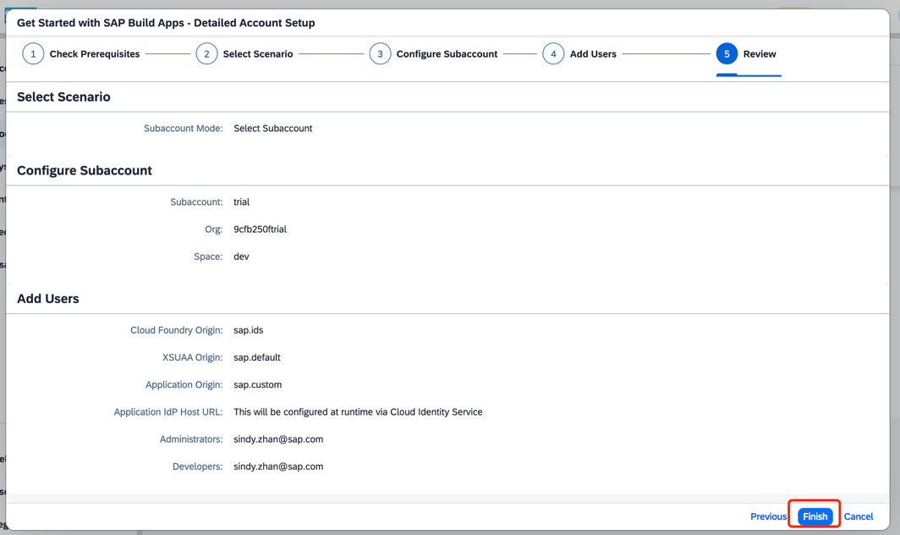
After booster executed successfully, SAP Build Apps, Cloud Identity Services, and SAP Build Work Zone, standard edition are all set up. | 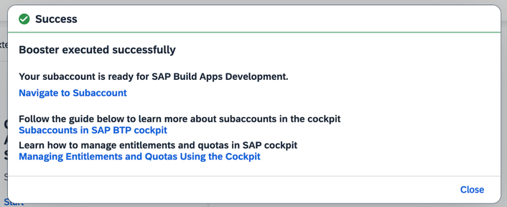
For Cloud Identity Services, you will receive an email to ask to you activate your account as admin for the newly created IAS tenant, click the button | 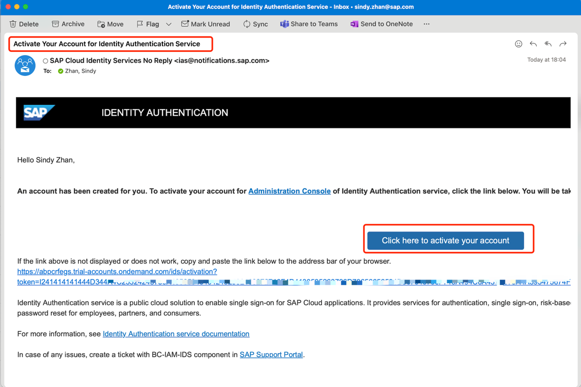
Set a password as told, click “Continue” | 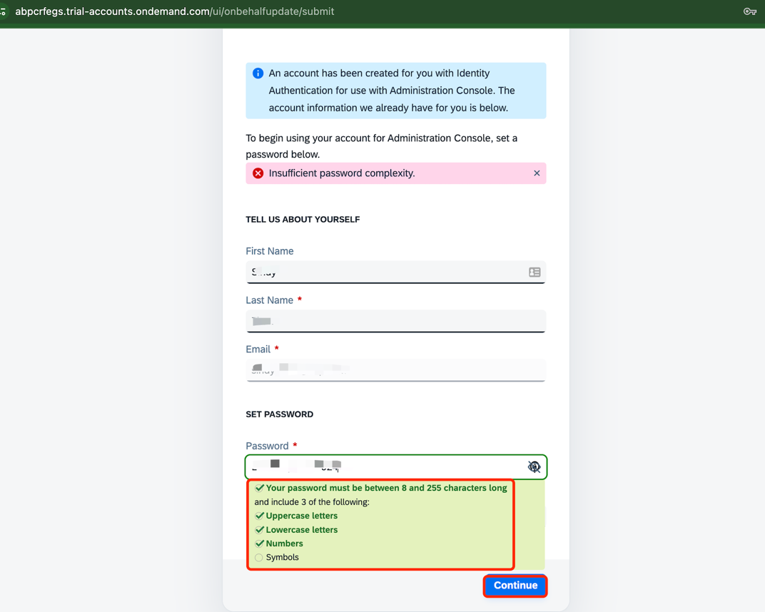
Your Cloud Identity Services will be opened, the link is <your-random-id>.trial-accounts.ondemand.com/admin/, you can bookmark it for later use | 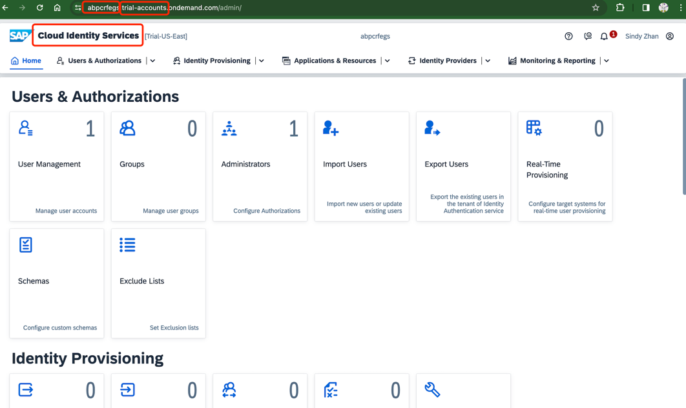
Go back to BTP Cockpit, your subaccount, under “Services” > “Instance and Subscriptions”, click “SAP Build Apps” | 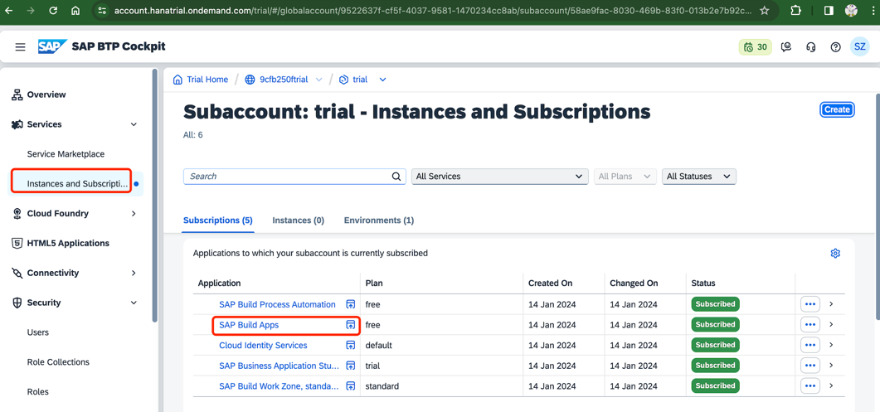
You can now open the app, and see the url is <global-account>.<region>.build.cloud.sap, you can bookmark it for later use. | 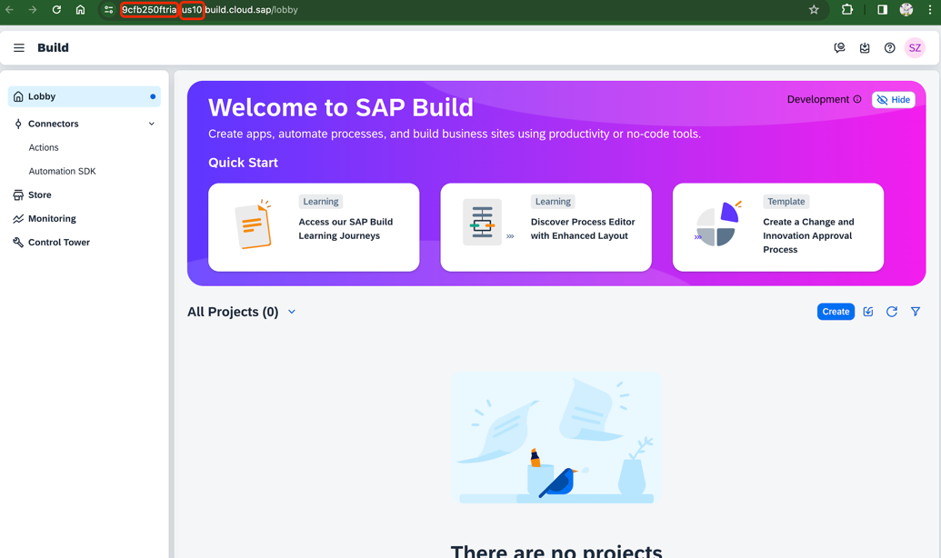
Click “Entitlements”, search for “process automation”, make sure the plan “free (application)” is assigend to your subaccount | 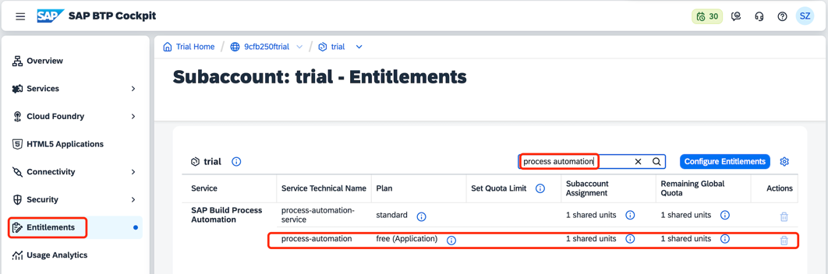
Click “Service Marketplace” under “Services”, search for “process automation”, and click the three dots on the upper-right of the search result, click “Create” | 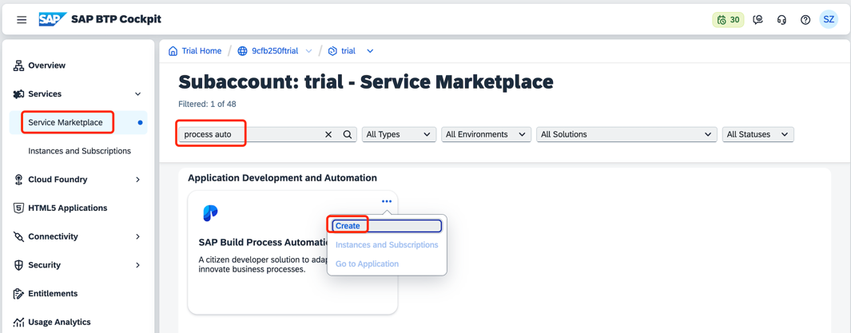
In the pop up wizard window, choose “Free” in the drop down list for Plan, click “Create” | 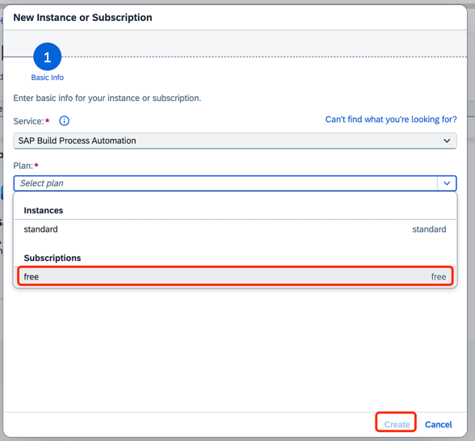
Go to “Users” under “Security”, choose yourself in the newly added identity provider (Custom IAS tenant, not the default identity provider), click three dots under “Role Collections”, click “Assign Role Collections” | 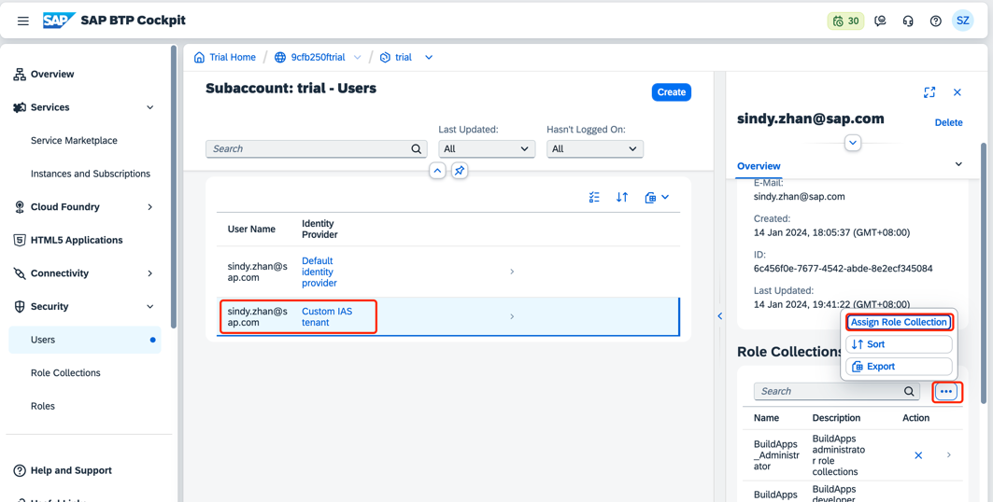
Choose all three roles related to “Process Automation”, click “Assign Role Collection” | 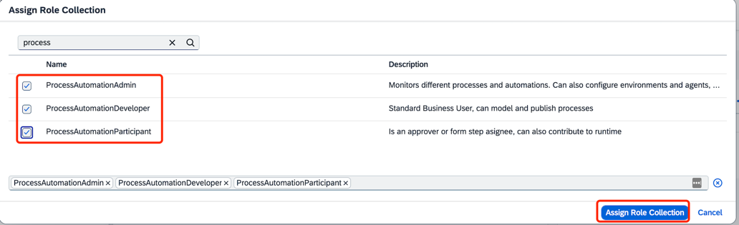
Under “Services” > “Instances and Subscriptions”, under “Subscriptions” > “Application”, see the status of SAP Build Process Automation turns subscribed, click to open the application. | 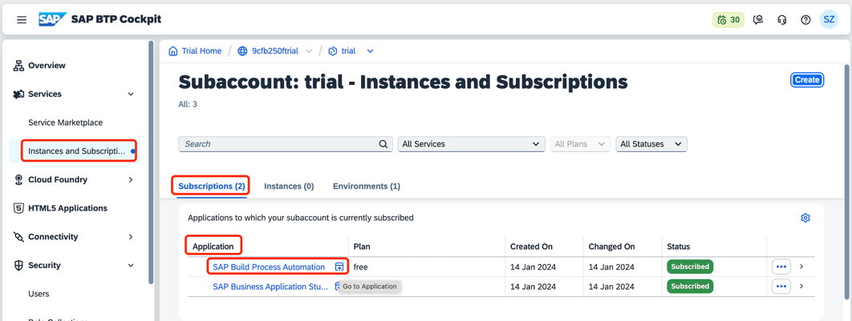
You will open the same SAP Build portal as the SAP Build Process Automation, click “Create” | 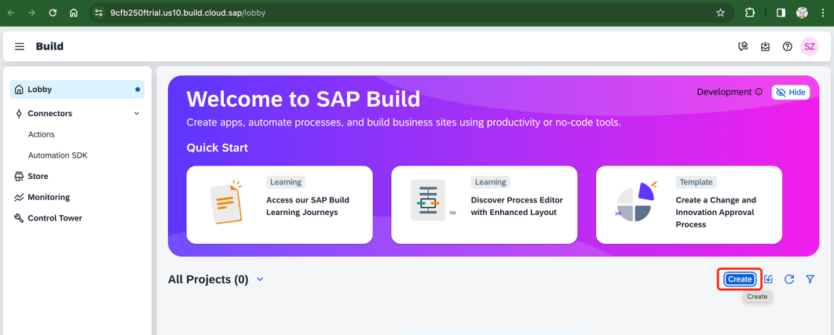
You will find that you are able to create projects for “SAP Build Process Automation” or “SAP Build Apps” | 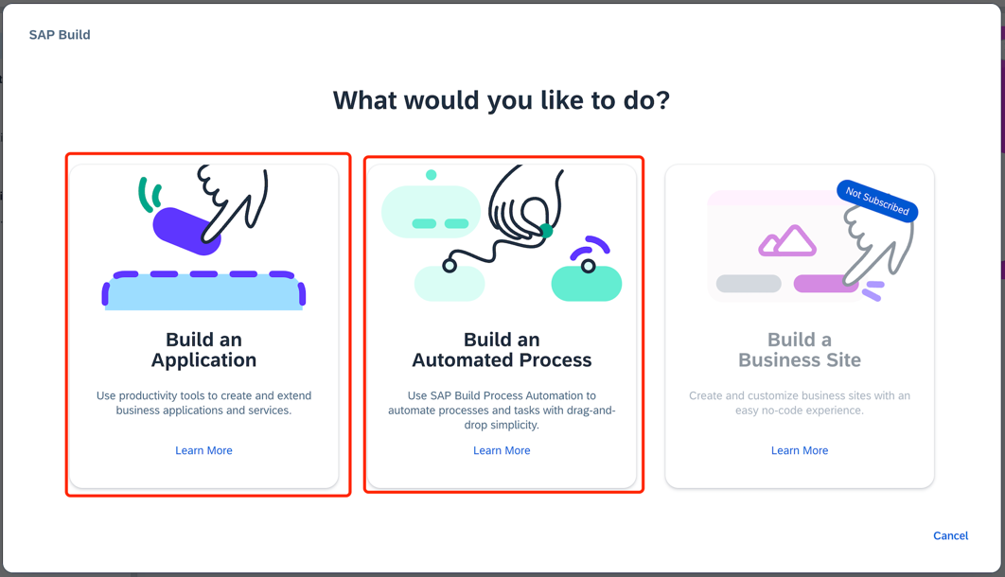
go to "Control Tower", click tile "Agents", and click "Download Agent" on the upper-right corner | 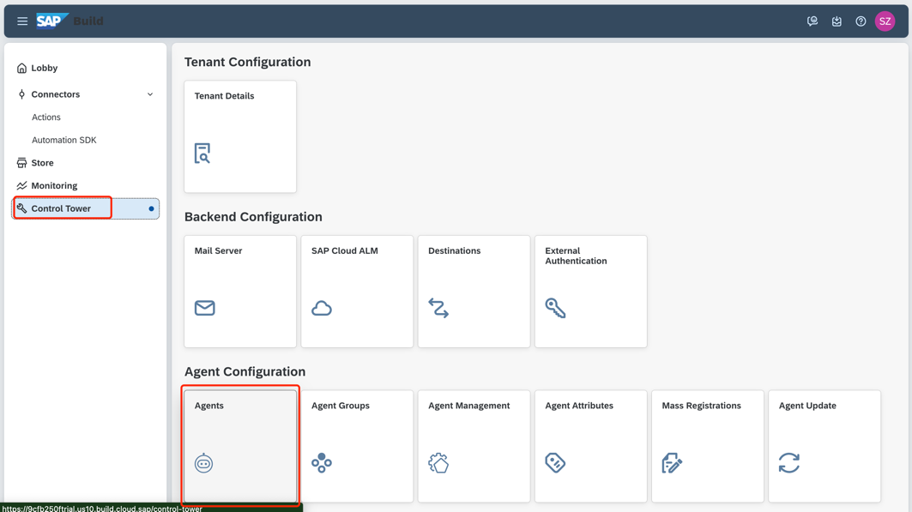  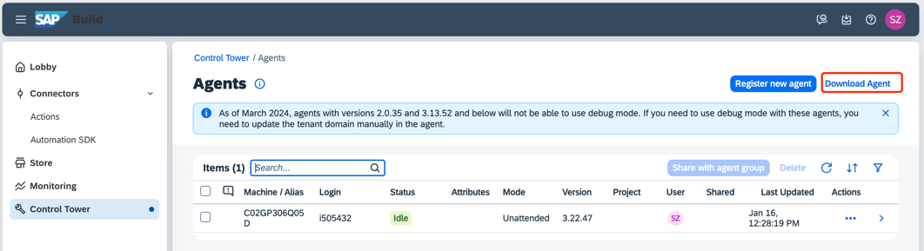
Follow the steps to install the agent, extension, and register the agent | 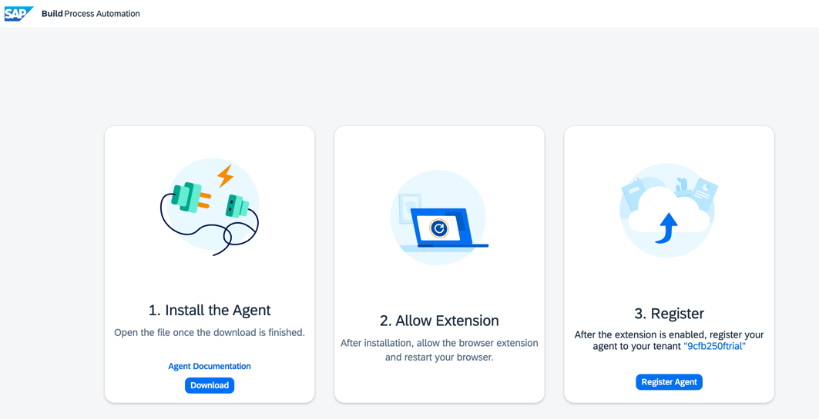
if you cannot download the mac version by clicking the download button, you can go here to download the version that works for your machine  https://tools.hana.ondemand.com/#cloud | 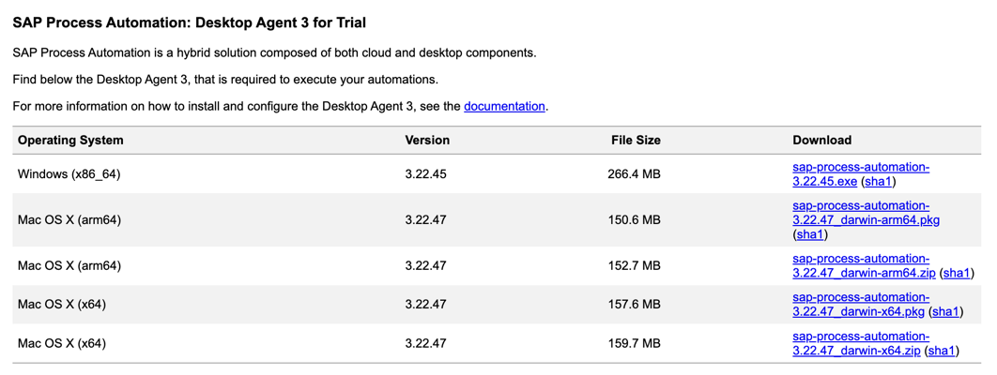
Start the downloaded installation package by double-click, follow the instruction and install the desktop agent, during the meanwhile, browser extension will also be installed for you. | 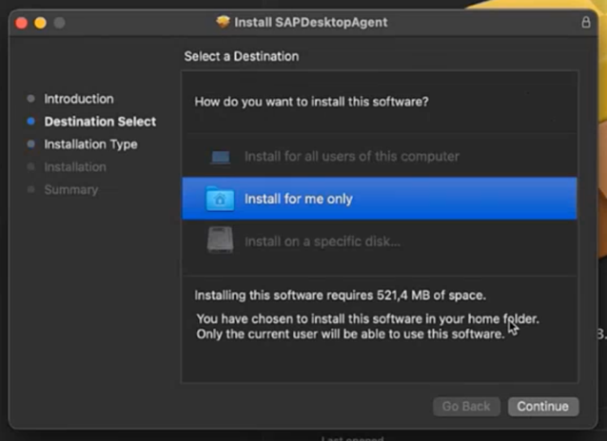
In case the extension is not installed, go to https://help.sap.com/docs/intelligent-robotic-process-automation/installation-guide/configuring-web-browsers and follow the instruction to add extension to your browser manually | 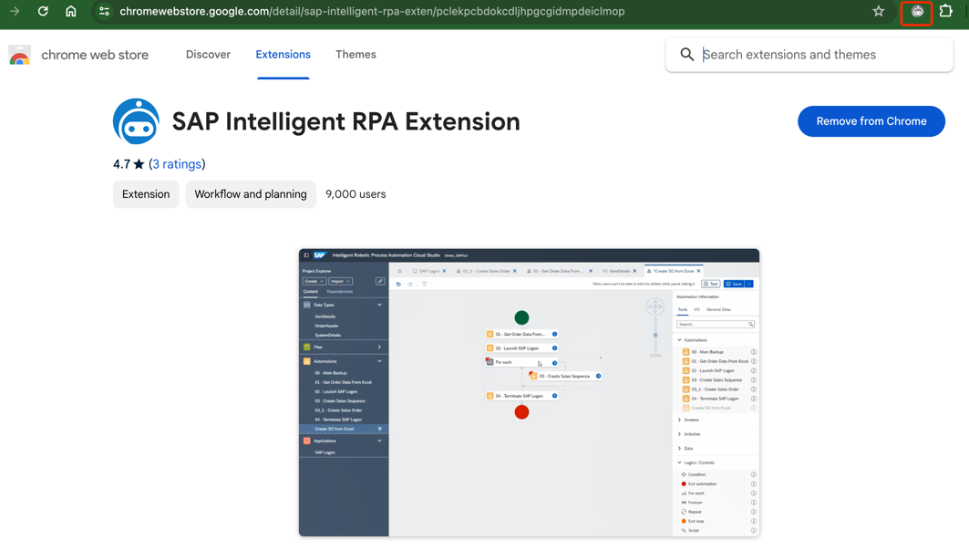
Refresh the installation page, and click "Register Agent". | 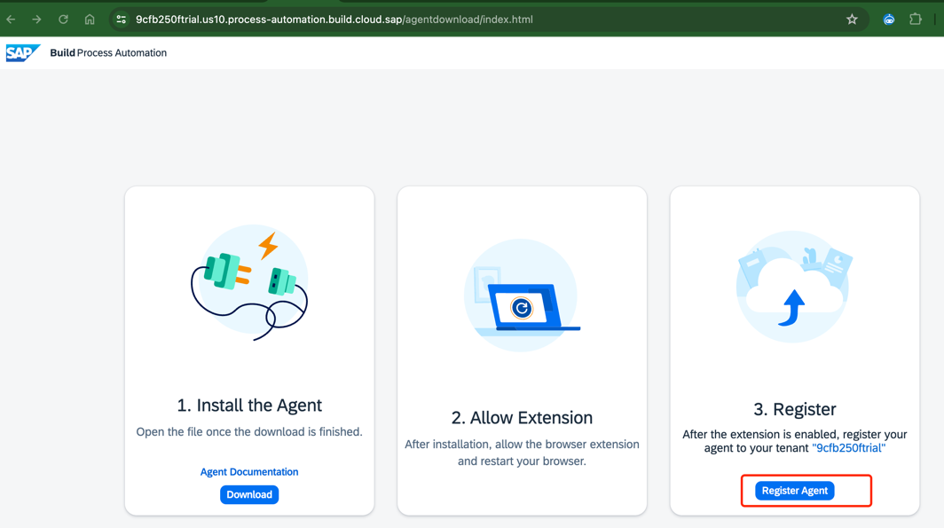
Open the agent, click "Select", and the tenant is registered and activated. | 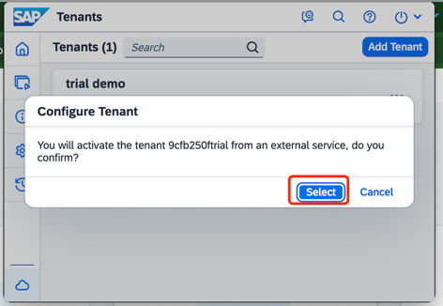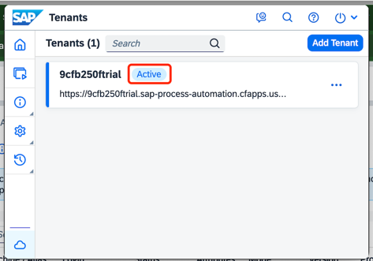
Install Preview app on mobile devices (from GooglePlay for Android phone or Apple Store for iPhone) | Android phone scans here iPhone scans here   

